**Coding Challenge SQL**

**Virtual Art Gallery Shema DDL and DML**

**Schema Design:**

**1. Artists table:**

CREATE TABLE Artists (

ArtistID INT PRIMARY KEY,

Name VARCHAR(255) NOT NULL,

Biography TEXT,

Nationality VARCHAR(100)

);

**2. Categories table:**

CREATE TABLE Categories (

CategoryID INT PRIMARY KEY,

Name VARCHAR(100) NOT NULL

);

**3. Artworks table:**

CREATE TABLE Artworks (

ArtworkID INT PRIMARY KEY,

Title VARCHAR(255) NOT NULL,

ArtistID INT,

CategoryID INT,

Year INT,

Description TEXT,

ImageURL VARCHAR(255),

FOREIGN KEY (ArtistID) REFERENCES Artists (ArtistID),

FOREIGN KEY (CategoryID) REFERENCES Categories (CategoryID)

);

**4. Exhibitions table:**

CREATE TABLE Exhibitions (

ExhibitionID INT PRIMARY KEY,

Title VARCHAR(255) NOT NULL,

StartDate DATE,

EndDate DATE,

Description TEXT

);

**5. ExhibitionArtworks table:**

CREATE TABLE ExhibitionArtworks (

ExhibitionID INT,

ArtworkID INT,

PRIMARY KEY (ExhibitionID, ArtworkID),

FOREIGN KEY (ExhibitionID) REFERENCES Exhibitions (ExhibitionID),

FOREIGN KEY (ArtworkID) REFERENCES Artworks (ArtworkID)

);

**Sample Datas:**

**1. Artists table:**

INSERT INTO Artists (ArtistID, Name, Biography, Nationality) VALUES

(1, 'Pablo Picasso', 'Renowned Spanish painter and sculptor.', 'Spanish'),

(2, 'Vincent van Gogh', 'Dutch post-impressionist painter.', 'Dutch'),

(3, 'Leonardo da Vinci', 'Italian polymath of the Renaissance.', 'Italian');

**2. Categories table:**

INSERT INTO Categories (CategoryID, Name) VALUES

(1, 'Painting'),

(2, 'Sculpture'),

(3, 'Photography');

**3. Artworks table:**

INSERT INTO Artworks (ArtworkID, Title, ArtistID, CategoryID, Year, Description, ImageURL) VALUES (1, 'Starry Night', 2, 1, 1889, 'A famous painting by Vincent van Gogh.', 'starry_night.jpg'),

(2, 'Mona Lisa', 3, 1, 1503, 'The iconic portrait by Leonardo da Vinci.', 'mona_lisa.jpg'),

(3, 'Guernica', 1, 1, 1937, 'Pablo Picasso\'s powerful anti-war mural.', 'guernica.jpg');

**4. Exhibitions table:**

INSERT INTO Exhibitions (ExhibitionID, Title, StartDate, EndDate, Description) VALUES

(1, 'Modern Art Masterpieces', '2023-01-01', '2023-03-01', 'A collection of modern art masterpieces.'),

(2, 'Renaissance Art', '2023-04-01', '2023-06-01', 'A showcase of Renaissance art treasures.');

**5. ExhibitionArtworks table:**

INSERT INTO ExhibitionArtworks (ExhibitionID, ArtworkID) VALUES

(1, 1),

(1, 2),

(1, 3),

(2, 2);

**Solve the below queries:**

**1. Retrieve the names of all artists along with the number of artworks they have in the gallery, and list them in descending order of the number of artworks.**

SELECT a.Name, COUNT(ar.ArtworkID) AS ArtworkCount

FROM Artists a

LEFT JOIN Artworks ar ON a.ArtistID = ar.ArtistID

GROUP BY a.Name

ORDER BY ArtworkCount DESC;

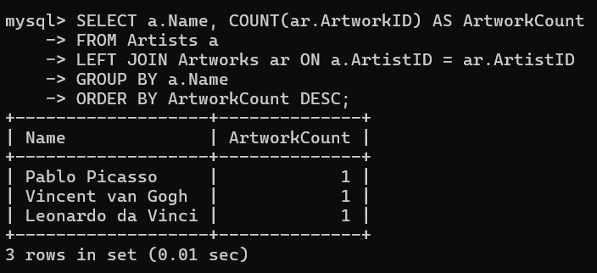

**2. List the titles of artworks created by artists from 'Spanish' and 'Dutch' nationalities, and order them by the year in ascending order.**

SELECT ar.Title, ar.Year

FROM Artworks ar

JOIN Artists a ON ar.ArtistID = a.ArtistID

WHERE a.Nationality IN ('Spanish', 'Dutch')

ORDER BY ar.Year ASC;

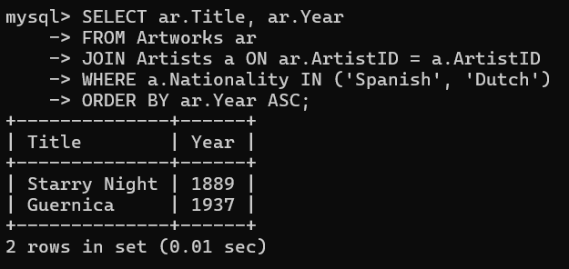

**3. Find the names of all artists who have artworks in the 'Painting' category, and the number of artworks they have in this category.**

SELECT a.Name, COUNT(ar.ArtworkID) AS ArtworkCount

FROM Artists a

JOIN Artworks ar ON a.ArtistID = ar.ArtistID

JOIN Categories c ON ar.CategoryID = c.CategoryID

WHERE c.Name = 'Painting'

GROUP BY a.Name;

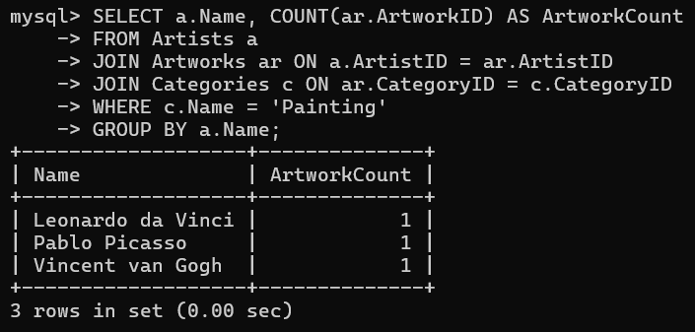

**4. List the names of artworks from the 'Modern Art Masterpieces' exhibition, along with their artists and categories.**

SELECT ar.Title, a.Name AS ArtistName, c.Name AS CategoryName

FROM ExhibitionArtworks ea

JOIN Artworks ar ON ea.ArtworkID = ar.ArtworkID

JOIN Artists a ON ar.ArtistID = a.ArtistID

JOIN Categories c ON ar.CategoryID = c.CategoryID

JOIN Exhibitions e ON ea.ExhibitionID = e.ExhibitionID

WHERE e.Title = 'Modern Art Masterpieces';

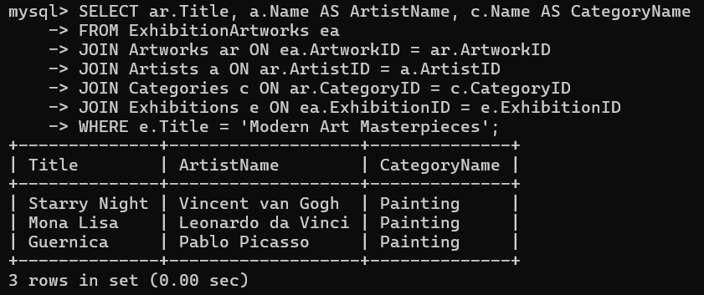

**5. Find the artists who have more than two artworks in the gallery.**

SELECT a.Name

FROM Artists a

JOIN Artworks ar ON a.ArtistID = ar.ArtistID

GROUP BY a.Name

HAVING COUNT(ar.ArtworkID) > 2;

***[ It is a empty set because there is no artists who have more than two artworks]***



**6. Find the titles of artworks that were exhibited in both 'Modern Art Masterpieces' and 'Renaissance Art' exhibitions.**

SELECT ar.Title

FROM Artworks ar

JOIN ExhibitionArtworks ea1 ON ar.ArtworkID = ea1.ArtworkID

JOIN Exhibitions e1 ON ea1.ExhibitionID = e1.ExhibitionID

JOIN ExhibitionArtworks ea2 ON ar.ArtworkID = ea2.ArtworkID

JOIN Exhibitions e2 ON ea2.ExhibitionID = e2.ExhibitionID

WHERE e1.Title = 'Modern Art Masterpieces' AND e2.Title = 'Renaissance Art';

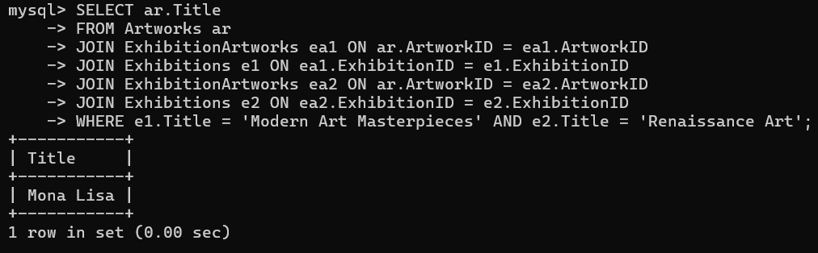

**7. Find the total number of artworks in each category.**

SELECT c.Name, COUNT(ar.ArtworkID) AS TotalArtworks

FROM Categories c

LEFT JOIN Artworks ar ON c.CategoryID = ar.CategoryID

GROUP BY c.Name;

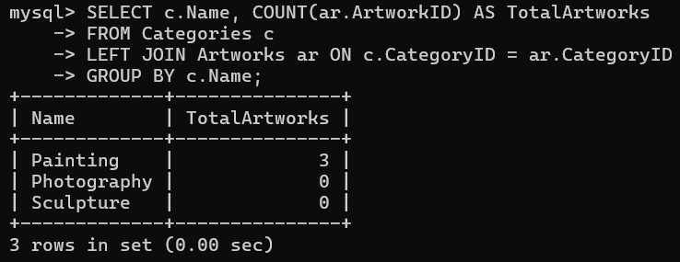

**8. List artists who have more than 3 artworks in the gallery.**

SELECT a.Name

FROM Artists a

JOIN Artworks ar ON a.ArtistID = ar.ArtistID

GROUP BY a.Name

HAVING COUNT(ar.ArtworkID) > 3;

***[ It is a empty set and It is similar to Q.no-5 but difference in count(Artworks)]***



**9. Find the artworks created by artists from a specific nationality (e.g., Spanish).**

SELECT ar.Title

FROM Artworks ar

JOIN Artists a ON ar.ArtistID = a.ArtistID

WHERE a.Nationality = 'Spanish';

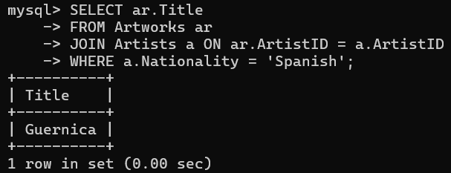

**10. List exhibitions that feature artwork by both Vincent van Gogh and Leonardo da Vinci.**

SELECT e.Title

FROM Exhibitions e

JOIN ExhibitionArtworks ea ON e.ExhibitionID = ea.ExhibitionID

JOIN Artworks ar ON ea.ArtworkID = ar.ArtworkID

JOIN Artists a ON ar.ArtistID = a.ArtistID

WHERE a.Name IN ('Vincent van Gogh', 'Leonardo da Vinci')

GROUP BY e.Title

HAVING COUNT(DISTINCT a.Name) = 2;

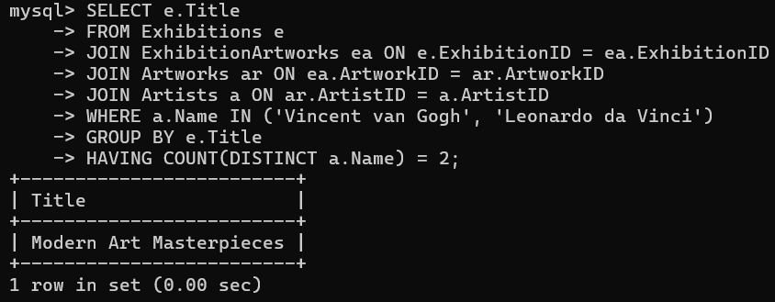

**11. Find all the artworks that have not been included in any exhibition.**

SELECT ar.Title

FROM Artworks ar

LEFT JOIN ExhibitionArtworks ea ON ar.ArtworkID = ea.ArtworkID

WHERE ea.ExhibitionID IS NULL;

***[ It is a empty set because all the artworks are included in exhibition.]***



**12. List artists who have created artworks in all available categories.**

SELECT a.Name

FROM Artists a

JOIN Artworks ar ON a.ArtistID = ar.ArtistID

JOIN Categories c ON ar.CategoryID = c.CategoryID

GROUP BY a.Name

HAVING COUNT(DISTINCT c.CategoryID) = (SELECT COUNT(*) FROM Categories);

***[ It is a empty set because there is no artists who have created artworks in all available categories]***

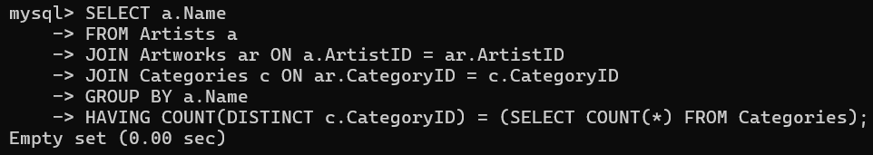

**13. List the total number of artworks in each category.**

***[ This question is similar to Q.no-7]***

**14. Find the artists who have more than 2 artworks in the gallery.**

***[ This question is similar to Q.no-5]***

**15. List the categories with the average year of artworks they contain, only for categories with more than 1 artwork.**

SELECT c.Name, AVG(ar.Year) AS AvgYear

FROM Categories c

JOIN Artworks ar ON c.CategoryID = ar.CategoryID

GROUP BY c.Name

HAVING COUNT(ar.ArtworkID) > 1;

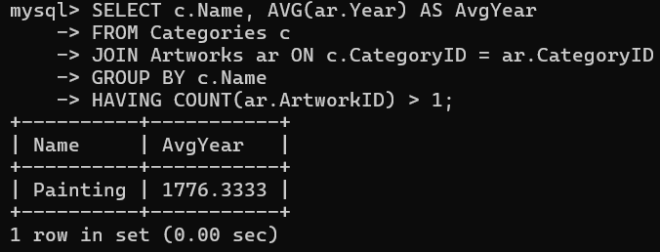

**16. Find the artworks that were exhibited in the 'Modern Art Masterpieces' exhibition.**

SELECT ar.Title

FROM Artworks ar

JOIN ExhibitionArtworks ea ON ar.ArtworkID = ea.ArtworkID

JOIN Exhibitions e ON ea.ExhibitionID = e.ExhibitionID

WHERE e.Title = 'Modern Art Masterpieces';

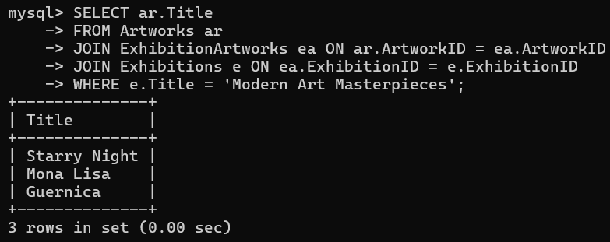

**17. Find the categories where the average year of artworks is greater than the average year of all artworks.**

SELECT c.Name

FROM Categories c

JOIN Artworks ar ON c.CategoryID = ar.CategoryID

GROUP BY c.CategoryID, c.Name

HAVING AVG(ar.Year) > (SELECT AVG(Year) FROM Artworks);

***[ It is a empty set]***

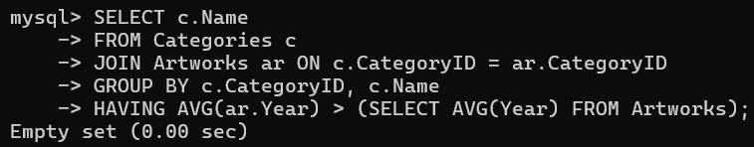

**18. List the artworks that were not exhibited in any exhibition.**

***[ This question is similar to Q.no-11]***

**19. Show artists who have artworks in the same category as "Mona Lisa."**

SELECT DISTINCT a.Name

FROM Artists a

JOIN Artworks ar ON a.ArtistID = ar.ArtistID

WHERE ar.CategoryID = (SELECT CategoryID FROM Artworks WHERE Title = 'Mona Lisa');

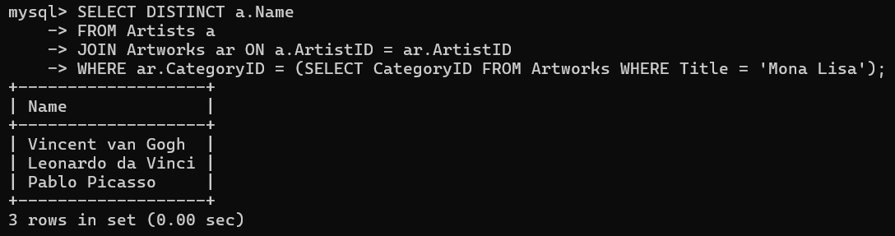

**20. List the names of artists and the number of artworks they have in the gallery.**

SELECT a.Name, COUNT(ar.ArtworkID) AS ArtworkCount

FROM Artists a

LEFT JOIN Artworks ar ON a.ArtistID = ar.ArtistID

GROUP BY a.Name;

***[ This question is similar to Q.no-1 but here I used JOINS]***

